Excel Guidelines for the Individual Project

- Have one tab for selected items from the financial statement and another tab to calculate ratios.

See below for an example. In particular, look at how the Current Ratio for 2010 is calculated in the “Trend and Ratio Analysis” tab.

*Notice that inputs (typed in numbers) are in blue (per industry standard) and formulas are in black.

*** Note: Numbers are made up and not from Nordstrom’s actual financials.

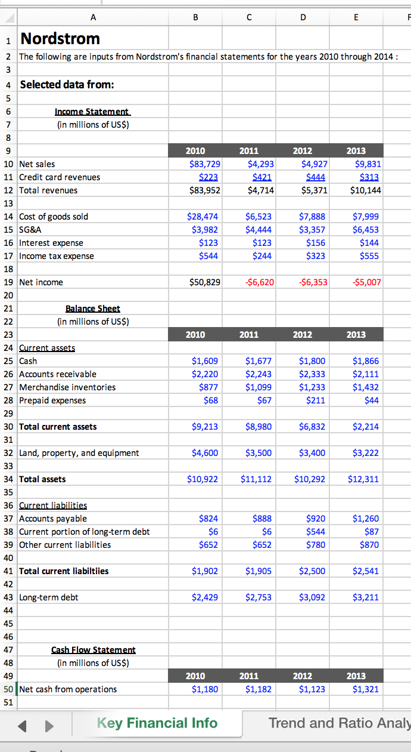

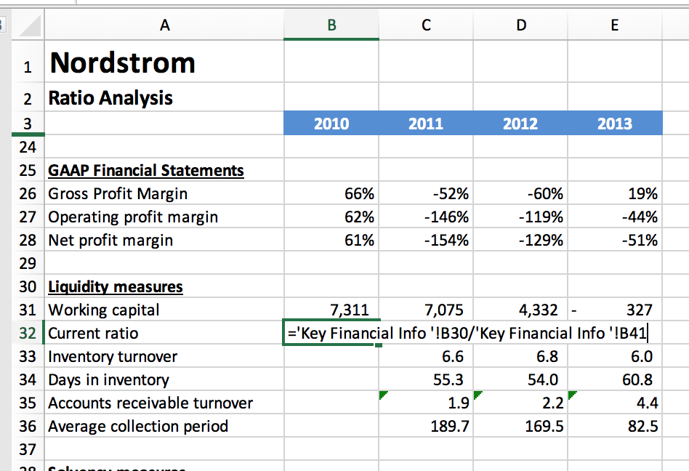
Do this instead of putting in =4,824/1,879.

You’ll get the same answer but referring to the numbers in the “Key Financial Info” tab allows you to minimize mistakes (and you can copy and paste this formula to other years)

- Professionalism: At a minimum:
  - Font size and font type should be consistent across the page
  - Numbers should be rounded (one decimal is good)

For extra help in Excel, here are some resources:

- Lynda.com (online tutorials – just search for “basic Excel”)

Free for USC students (using your USC Student ID and password):

https://itservices.usc.edu/lynda/

- Professor Julie Suh’s book on financial modeling using Excel

E-book or hard copy available directly from the publisher:

https://he.kendallhunt.com/product/model-boss-excel-tutorial-financial-modeling

Also available on Amazon:

https://www.amazon.com/Model-Like-Boss-Tutorial-Financial/dp/152492170X/ref=sr_1_1?ie=UTF8&qid=1534973471&sr=8-1&keywords=model+like+a+boss

